Occam’s Protocol:

- Lifting
  - Workout A
  - Workout B
- Frequency
- Feeding
- Prescriptions

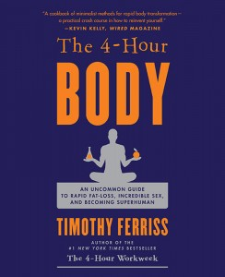

“It is possible to get huge with less than 30 minutes of gym time per week. “

WORKOUT A: (Machine Option)
Workout (A) consists of two primary lifts + (optional) abdominal exercises from “six minute Abs”
I. Close-Grip Supinated (palms facing you) Pull Down x 7 reps (5/5 count)
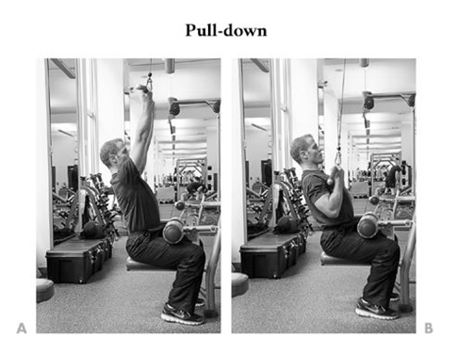
II. Machine Shoulder Press x 7 reps (5/5 count)
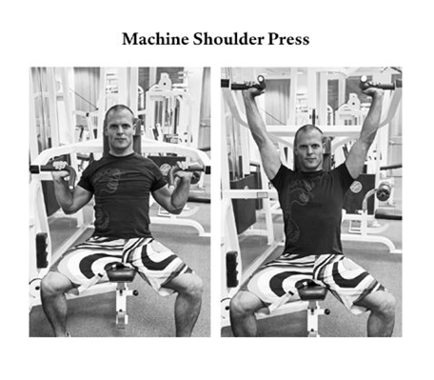

(Optional)
III. Two Abdominal Exercises from “Six-Minute Abs”
Movement #1: Thy Myotatic Crunch
- Start with arms stretched overhead as high as possible. Keep arms behind or next to your ears for the entire exercise.
- Lower under control 4 seconds until your fingers touch the floor.
- Pause at the bottom for 2 seconds.
- Rise under control and pause in the upper fully contracted position for 2 seconds.
- Repeat for a total of 10 rep.
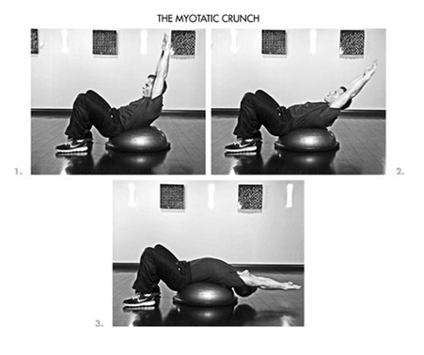
Movement # 2: The Cat Vomit Exercise
- Get on all fours and keep your gaze focused either directly under your head or slightly in front of you. Don’t arch your back or strain your neck
- Forcefully exhale from your mouth until air is fully expelled.
- Hold your breath and pull your belly button upward toward your spine as hard as you can for a target of 8-12 seconds.
- Inhale fully through the nose after the 8-12 second hold.
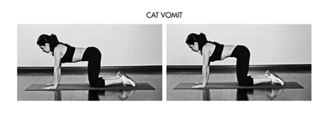

WORKOUT B: (Machine Option)
Workout (B) consists of two primary lifts + (optional) Kettlebell or T-Bar swings from “Building the Perfect Posterior

I. Slight incline/decline bench press x 7 (5/5 count)
- To prevent unnecessary shoulder strain, set the pins in the machine so that your knuckles are one first width above your chest at the bottom of the movement
- Take a one-second pause at the bottom of the movement without touching the weight stack

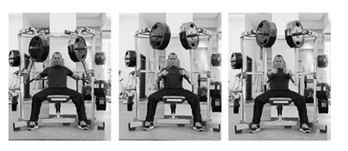

II. Leg press x 10 (5/5 count)
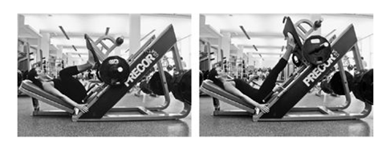
(Optional)
III. Kettlebell or T-bar swings
- High-rep kettlebell (53 pounds) swings to at least 75 rps
- Stand with your feet 6-12 inches outside of shoulder width on either side, each foot pointed outward about 30 degrees. If toes pointed straight ahead were 12:00 on a clock face, your foot would point at 10:00 or 11:00, and your right would point at 1:00 or 2:00
- Keep your shoulder pulled back and down to avoid rounding your back
- The lowering movement is a sitting-back-on-a-chair movement, not a squatting-down movement.
- Do not let your shoulders go in front of your knees at any point
- Imagine pinching a penny between your butt cheeks when you pop your hips forward. This should be a forceful pop, and it should be impossible to contract your ass more.

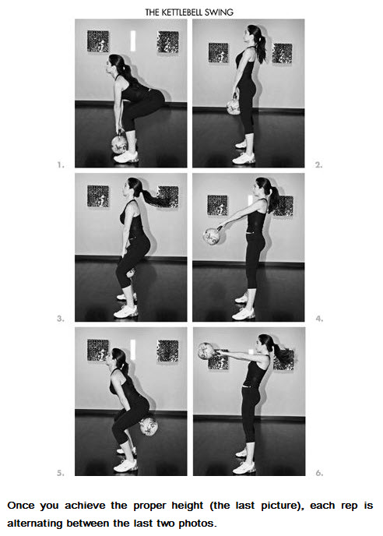

Occam’s Frequency:
- Begin Occam’s Protocol with two days between A and B workouts.
- After two of both the A and B workouts, increase the rest days between workouts to three days.
- As soon as you have a workout where more than one exercise has stalled (indicated in our hypothetical calendars with the B*), but not before, increase to four days between workouts.
- Continue adding rest as needed to resolve plateaus until you hit your target weight.
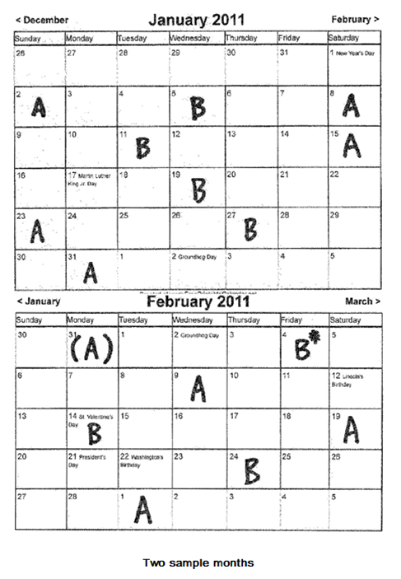

Occam’s feeding:
- The Meal Composition is nearly identical to the Slow Carb Diet
- You will add a starch such as brown rice or quinoa to the non-shake meals
  - 7:00 A.M. – Wake up, immediately breakfast + 1/2 morning shake
  - 8:30 A.M. – Training, if scheduled (I sip low fat protein just before and throughout. Tim recommended (Isopure Brand)
  - 30 minutes post training (high protein snack)
  - 2:00 P.M. lunch
  - 6:00 P.M. Dinner
  - 15 minutes before bed-second half of morning shake
If you skip breakfast, use this blended mix:
Morning Shake
caloric and protein profile with 2% milk: 970 cal, 75 g protein
- 24 oz (3 cups) 2% whole milk
- 30 g whey protein isolate (chocolate tends to work best)
- 1 banana
- 3 heaping tablespoon almond butter with no added sugar
- 5 ice cubes

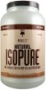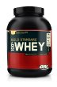

Occam’s Prescriptions:
- Cissus Quadrangularis: 2,400 mg three times per day
- Alpa-Lipoid Acid: 300mg, 30 minutes before each whole food meal
- L-Glutamine:
  - Consume 80 grams during the first five days of Occam’s Protocol
    - 10 grams every 2 hours on the dot until 80-gram quota is reached
  - After the Initial five day loading period:
    - 10-30 grams post workout will speed repair and help prevent soreness
- Creatinine Monohydrate:
  - For 28 days:
    - Consume 3.5 gams upon waking
    - Consume 3.5 grams before bed
  - if you use powder, mix in 5-6 grams total as losing one to two grams in solution is hard to avoid.

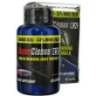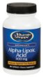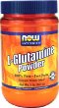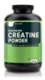

To Determine Starting Weights:
- Perform sets of 5 repetitions of each exercise with one minute of rest in between.
- Cadence should be fast but controlled on the raising and two to three seconds on the lowering.
- Do not perform more than 5 reps per set.
- If you can lift more, wait a minute, increase the weight ten pounds or 10% (whichever is less), and attempt again. Repeat this until you complete fewer than 5 reps.
- After you fail to complete 5 reps, calculate 70% of your last full five rep set.
- Take a 3 minute rest and perform a 5/5 cadence set to failure using this weight.
- Congratulations, you just performed your first proper set to failure for this exercise, and this weight will be your starting point for Occam’s Protocol.
EXAMPLE: 150 lbs male doing the Close-Grip Supinated (palms facing you) Pull Down
- 90 lbs x 5 reps (fast on lift and 2 seconds on release)
  - (1 minute rest)
- 100 lbs x 5 reps (fast on the lift and 2 seconds on the release)
  - (1 minute rest)
- 110 lbs x 5 reps (fast on the lift and 2 seconds on the release)
  - (1 minute rest)
- 120 lbs x 5 reps (fast on the lift and 2 seconds on the release)
  - (1 minute rest)
- 130 lbs x 4 reps (fast on the lift and 2 seconds on the release) (he failed to complete 5 reps, so 120 lbs was the last full 5 rep set)
Then the math:

  - take 70% of the weight of the last full 5 rep set
    - 120 x 0.7 =84
    - we round up or down to the nearest weight we can actually use on a machine or bar, which leads to 85 lbs
(3 minutes of rest)
- 85 lbs x 8 reps to failure (5 seconds on the lift and 5 seconds down)
Take a 5 minute rest, then repeat this process with the Machine Shoulder Press. Once finished with this workout A, record the target weights you will use for your next A.

To Add Weight:
- Complete your required minimum of reps (7 in Occam’s Protocol)
- add 10 pounds or 10% of the total weight in the subsequent workout, whichever is greater.
- In the example above, we crossed our seven-rep threshold with 85 pounds in the pull-down, so we will increase the weight to 95 pounds for the next workout, as a 10% increase would be less at 93.5 pounds.
- To maintain this rate of progress for even two months, you will need to eat like it’s your job. Add shakes or milk if whole food is too difficult.

If you miss a day or you miss your target repetitions:
- If you miss a day take an additional one to three days off, then return to your normal routing.
- If you miss your target number of repetitions by more than one repetition on the first exercise of a given workout, go home, take the next day off, then repeat the workout.
Let’s say you’re scheduled for workout A on a Monday. The first exercise is close-grip pull-downs, and your target number of repetitions is a minimum of seven. If you complete six good repetitions or more, complete the entire workout. If you don’t complete six repetitions for pull-downs, do NOT proceed to the shoulder press. Instead, pick up your gym bag and go home. Rest Tuesday, ensure proper nutrient intake by eating a ton, and come in Wednesday prepared to crush both exercises and proceed as planned. If you fail before the requisite number of reps, do not—as many people do—decrease the weight and do another set (called a “drop-down” or “break-down” set). Do nothing but leave. If you haven’t recovered, you haven’t recovered. Continuing can easily stagnate you for two weeks or more. Cutting a workout short takes tremendous self-control and runs counter to gym culture. Be smart and opt for a 48-hour reboot instead of a two-week or three- week reboot. Last but not least, if you abandon a workout because you miss a set, add another recovery day between all workouts moving forward. In effect, you’re just accelerating the planned decrease in frequency. There is very little downside to doing this. Twenty-four hours of additional time cannot hurt you, but underrecovering will screw up the entire process.

